Scientific Conference Participation Application form

Conference Paper Title:
Full Name: Click or tap here to enter text. | Position/Title: Click or tap here to enter text.
Faculty: Click or tap here to enter text. | Email Address: Click or tap here to enter text.
Phone Number: Click or tap here to enter text. | Co-authors (if any): Click or tap here to enter text.
Affiliation(s) / University or Institution of Co-author(s): Click or tap here to enter text.
Conference Type:
☐ International -A conference held outside the Middle East - Upon approval, applicants are required to complete the official letter addressed to the University Headquarters (HQ) and submit it to the R&D Office.
☐ Regional -A conference held in a Middle Eastern/Arabic country
Conference Full Name: Click or tap here to enter text. | Conference Website: Click or tap here to enter text.
Location (City):Click or tap here to enter text. | Country: Click or tap here to enter text.
Registration Fees: Click or tap here to enter text. | Presentation Date (if known): Click or tap here to enter text.
Organizing Body/Association: Click or tap here to enter text. | Date of Last Conference Participation (within the past 12 months): Click or tap here to enter text.
Conference Dates: From: Click or tap here to enter text. To: Click or tap here to enter text.
Early Bird Registration Deadline (if applicable): Click or tap here to enter text.
The conference proceedings are indexed in a recognized international database:
☐Scopus ☐ Web of Science ☐ Other (please specify): Click or tap here to enter text.

Abstract (300-650 words):

Please check the documents you are attaching to this application:
☐ Acceptance Letter
☐ Conference Registration Confirmation (if available)
☐ Abstract
☐ Other Supporting Documents (please specify): Click or tap here to enter text.
☐ For international conferences, submission and acceptance of a full paper is required
Which UN SDG(s) does this align to (please select all that apply)  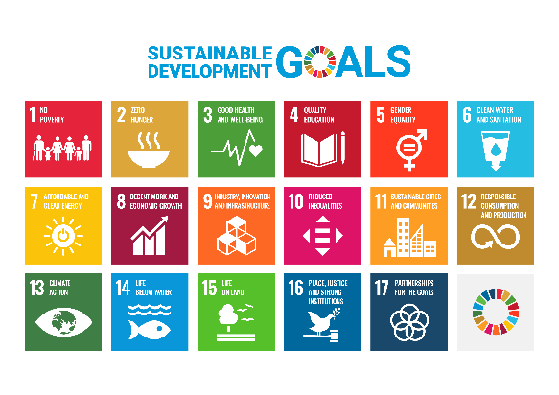 | ☐ SDG 1- No poverty  ☐ SDG 2- Zero hunger  ☐ SDG 3- Good health and well-being  ☐ SDG 4- Quality education  ☐ SDG 5- Gender equality  ☐ SDG 6- Clean water and sanitation  ☐ SDG 7- Affordable and clean energy  ☐ SDG 8- Decent work and economic growth  ☐ SDG 9- Industry, innovation and infrastructure  ☐ SDG 10- Reduced inequalities  ☐ SDG 11- Sustainable cities and communities  ☐ SDG 12- Responsible consumption and production  ☐ SDG 13- Climate action  ☐ SDG 14- Life below water  ☐ SDG 15- Life on land  ☐ SDG 16- Peace, justice and strong institutions  ☐ SDG 17- Partnerships for the goals

DECLARATION
I confirm that all information provided in this application is accurate and complete. The applicant commits to:
☐ Submitting a brief scientific report on the conference participation within fourteen (14) days of the conference conclusion and sending it to the Research & Development (R&D) Office.
☐ Delivering an internal seminar or presentation to share the academic outcomes of the conference within six months of participation.
☐ Providing the conference program/schedule indicating the date and time of the applicant’s presentation.

Signature: Click or tap here to enter text. Date: Click or tap here to enter text.

